SPEND A DAY HELPING STUDENTS LEARN A VERY IMPORTANT LESSON!
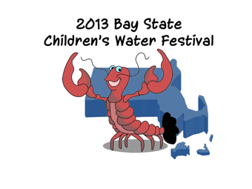
Holyoke Community College
June 6, 2013
This free festival for 1,500 local fifth grade students and their teachers
is designed to teach students about the importance of protecting our
water resources through a hands on learning experience. Water topics include drinking water, groundwater, watersheds, surface water, water quality, the water cycle, and conservation.
We need 300 volunteers to make this possible for the students of Massachusetts!
Please go to www.watersystemscouncil.org
to download volunteer information and view a video of the festival
Questions? Contact: Margaret Martens
mmartens@watersystemscouncil.org
202-625-4387

